13 If I speak in the tongues^{[a]} of men or of angels, but do not have love, I am only a resounding gong or a clanging cymbal. ² If I have the gift of prophecy and can fathom all mysteries and all knowledge, and if I have a faith that can move mountains, but do not have love, I am nothing. ³ If I give all I possess to the poor and give over my body to hardship that I may boast,^{[b]} but do not have love, I gain nothing.
⁴ Love is patient, love is kind. It does not envy, it does not boast, it is not proud. ⁵ It does not dishonor others, it is not self-seeking, it is not easily angered, it keeps no record of wrongs. ⁶ Love does not delight in evil but rejoices with the truth. ⁷ It always protects, always trusts, always hopes, always perseveres.
⁸ Love never fails. But where there are prophecies, they will cease; where there are tongues, they will be stilled; where there is knowledge, it will pass away. – 1 Corinthians 13: 1-8
⁷ Dear friends, let us love one another, for love comes from God. Everyone who loves has been born of God and knows God. ⁸ Whoever does not love does not know God, because God is love.
¹⁶ And so we know and rely on the love God has for us. God is love. Whoever lives in love lives in God, and God in them. – 1 John 4: 7-8, 16
In today’s culture, we use the words Love and Like that convey a wide variety of meaning: e.g. love my wife, my dog, ice cream, football, a movie, a restaurant . . . Like is a ______ with emotional attachments. Bible Love is a __________. Unlike modern English, the Bible, especially the New Testament ______ has four words in defining love. These words are very specific in meaning:
- Eros - _________ Love
- _________ Desire and Pleasure (Erotic)
- Longing for ______________________ Ecstasy
- It is __________ that can lead to Lust
- Storge - Mutual love and blood bonds of __________________ (Responsible tough love)
- Familial affection and appreciation of _______________________ (Psalms 22: 6)
- Rulers relationships with the subjects; Employer & Employees
- Phileo - Philos = Friend (_____________________)Romans 12: 9 -18)
- Philemia = Kiss (_________________________)
- Philosophia = Love of Knowledge (____________________________________)
- Philadelphia = Love of Brothers (City of __________________)
- Philoxenia = Love of Strangers (________________)
- Philanthropia = Love of Mankind (______________________________)
- Agape - Biblical & __________ Love with right attitude where the source is God’s character
- Meeting needs with benefits for ________ from God with no _________________
- Love with a foundation based on God’s _____________________
- Love for an _______ child
- Unconditional
- Sacrificial
- Heroic & _________
- Selfless
- Giving
- Forgiving
- God expects believers to model these attributes of Jesus Christ
- Agape Love is a Godly ___________
- Agape Love is ____________
- Agape Love Produce __________
In the Old Testament Hebrew, HESED is used to mean Lovingkindness that:
- Do what is right with long suffering! (_________________)
- Demonstrate Steadfast Love and Loyalty Love (Hosea _________)
- Deliver Love with Grace and Mercy (Kind, absorbs _________________; forgiving, not mean, not nasty, not ________________; keeps no records of ________ (2 Timothy 4: 6-16)
Know that God’s Love is the ____________ form and is uncaused, unreasonable, __________, unlimited, _________________ and uncomplicated.
In His Word, God the Father reveals to us that He loves:
- His _____ & ___________
- God loves the ________________ (Regenerated/born-again Jews and Gentiles)
- God loves the ____________ (John 3:16)
- God loves ________.
Know that our natural response is ______ – Resulting in separation from God. The unbeliever and believer exhibits Disloyalty, Betrayal and Abandonment by way of the Lust of the ______, Lust of the ________ and the Pride of ________. Our motives are self-serving, corrupted and not pure.
Know that we must ____________ our minds and growing to be Christlike (Romans 12: 1-2) and response ___________________. (Ephesians 5:1)
The Apostle Paul’s letters to the Churches talks about three key words: Faith, Hope and Love.
FAITH: Knowledge and Fear/Reverence of God – ____________________ (Hebrews 11: 1)
Acts of the Will - _________________
Experience – Joy, ________________ and Confidence
HOPE: 100 percent ______________ of future blessings (Absolute Certainty & Trust in God’s Promises)
LOVE: It is the ________ of the three. The relenting love of God (unyielding). It is part of God’s nature.
“Therefore, since we have been justified through faith, we have peace with God through our Lord Jesus Christ, through whom we have gained access by faith into this grace in which we now stand. And we boast in the hope of the glory of God. Not only so, but we also glory in our sufferings, because we know that suffering produces perseverance; perseverance, character; and character, hope. And hope does not put us to shame, because God’s love has been poured out into our hearts through the Holy Spirit, who has been given to us.” - Romans 5: 1-5
“We know love by this, that he laid down his life for us — and we ought to lay down our lives for one another” - 1 John 3:16
Here we glimpse the depth of the gift and the gravity of the demand. Christ gives unconditional love for us, even to the point of death.
“For God so loved the world, that he gave his only begotten Son, that whosoever believeth in him should not perish, but have everlasting life.” - John 3:16
“The Son radiates God's own glory and expresses the very character of God, and he sustains everything by the mighty power of his command. When he had cleansed ...” - Hebrews 1: 3
“Walk in Love - Therefore be imitators of God, as beloved children. And walk in love, as Christ loved us and gave himself up for us, a fragrant.” - Ephesians 5: 1-2
“Teacher, which is the greatest commandment in the Law?” Jesus replied: “ ‘Love the Lord your God with all your heart and with all your soul and with all your mind.’ This is the first and greatest commandment. And the second is like it: ‘Love your neighbor as yourself.’ All the Law and the Prophets hang on these two commandments.” - Matthew 22: 36-40
THE PRACTICE OF LOVE – How shall we live? Life of Faith, Hope, Love with Joy & Peace.
Requires intentions of the ________ to involve understanding, capacity and opportunities to ____________ Christ Agape Love and ___________ the Gospel message to the world.
TRUE INDICATORS & APPLICATIONAL ACTION PRINCIPLES – We are inclining to be:
- Honoring, Delighting and ______________ God daily and properly, individually & corporately.
- Trusting, Studying, Knowing and ______________ the Word of God
- Acknowledging, Praying, Imitating and ________ Christ and His Sovereignty, Holiness, Mercy & Grace
- Unwrapping His Spirit Gifts and ___________ Good Fruits for God and our Neighbors
- Edifying and ______________ other believers without expecting anything in return
- Exercising Contentment & friendly spirit in all situations ___________ in good deeds and truth.
- Acting and Working as a co-worker for and with __________, not for men (Colossians 3: 23)
- Being a Living Sacrifice (being Selfless and not Self-___________) - “Be Him in the World”
- Restraining the ___________ of Bitterness, Envy, Maliciousness, Cold Heartedness & Resentment
- Exhibiting sensitive concerns and empathy for benefitting _______ in need and during their suffering
- Helping, Serving, Supporting, Forgiving and ______ Generously rooted & reflected in God’s Character
- _____________, Edifying, Empowering and Ennobling one another
- Fulfilling our Destiny with __________ using our Grandmaster Key with a lifestyle of Repentance
- Praying for unsaved family members, friends, colleagues, students, teachers . . . in God’s _________.
- Loving the _____________ and even our enemies. (Matthew 5: 42-48; 22:36-40)
- Testing of our faith, hope and love through God’s challenges in our daily walk. Repenting when we ___________.
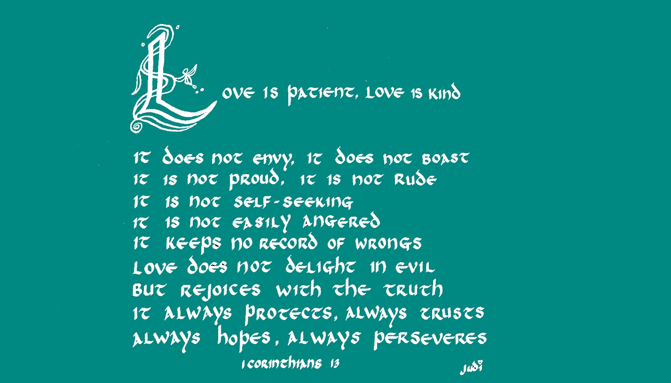
Job as a role model through difficult testing and his three statements of faith as a overcomer:
- Job 13: 3 - I ________ God if he slays me.
- Job 19 - I know my ______________ lives.
- Job 23: 10 - He knows and tests me, regardless of the ___________, I will come out like Gold.
Job ___________to:
- blame God;
- remains guiltless and
- releases his grief and sorrow to God.
² “The scribes and the Pharisees sit on Moses' seat, ³ so do and observe whatever they tell you, but not the works they do. For they preach, but do not practice. ⁴ They tie up heavy burdens, hard to bear,^{[a]} and lay them on people's shoulders, but they themselves are not willing to move them with their finger. ⁵ They do all their deeds to be seen by others. For they make their phylacteries broad and their fringes long, ⁶ and they love the place of honor at feasts and the best seats in the synagogues ⁷ and greetings in the marketplaces and being called rabbi^{[b]} by others. – Matthew 23: 2-7
- Be patient and _______
- Put others’ interests ahead of ______
- Check our motive to ensure to avoid ___________ and covetousness
- Will not be ________ easily (No short fuse & don’t be a Hot Head by controlling our temper)
- Think no ______.
- Keep no records of _________ or keep score (Commitment is 100 percent and not 50-50)
- Give others the Judgment of Charity (No __________ of Forethought)
- Give others the ___________ of the doubt
- Rejoice in _________
- Encourage one another toward Spiritual ___________
- Bear, endure, rely on God with Faith, Hope and __________ Love
- Do not envy/avoid ___________.
- Do not Boast (so we will not be _________ up and be proud)
- Do not ________ the spotlight
- Do not ________ to have our own way
- Do not ________ rudely.
- Act and conduct our transactions with ________ manners (Courtly Etiquette = Courtesy)
- Rejoice in others’ _____________
- __________ servanthood
- Always __________, always trusts, always hopes, always perseveres.

WHAT IS GOD’S WILL FOR US? GOD = LOVE

1 Therefore be imitators of God, as beloved children. Imitate God, therefore, in everything you do, because you are his dear children. Watch what God does, and then you do it, like children who learn proper behavior from their parents. Therefore, be imitators of God, as dearly loved children.
- Ephesians 5;1

